SUMMARY:

Publications in Prestigious Scientific Journals

I obtained my Ph.D. at the end of 2012 and have a very impressive publication records as evidenced by 16 peer-reviewed papers published in prestigious international and national scientific journals including PLoS One, Journal of Affective Disorders, Journal of Psychiatric Research, American Journal on Addictions, Progress in Neuro-Psychopharmacology and Biological Psychiatry, American Journal of Therapeutics, Human Psychopharmacology: Clinical and Experimental, Nutrients, Asia-Pacific Psychiatry, and the Journal of Clinical Neuroscience.

PLOS ONE is an international, peer-reviewed, open-access, online publication. PLOS ONE welcomes reports on primary research from any scientific discipline. It provides pen-access—freely accessible online, fast publication times, peer review by expert, practicing researchers, post-publication tools to indicate quality impact, and worldwide media coverage. PLoS One ranks #1 by impact factor among the top 50 cited scientific journals in the field of Medicine (miscellaneous).

Please note that the Journal of Affective Disorders publishes papers concerned with affective disorders in the widest sense: depression, mania, anxiety and panic. It is interdisciplinary and aims to bring together different approaches for a diverse readership. High quality papers will be accepted dealing with any aspect of affective disorders, including biochemistry, pharmacology, endocrinology, genetics, statistics, epidemiology, psychodynamics, classification, clinical studies and studies of all types of treatm According to the Scientific Journal Ranking published by the SCImago Journal & Country Rank, the Journal of Affective Disorders ranks #3 by impact factor among the top 50 cited scientific journals in the field of Psychiatry and Mental Health.

Please note that SCImago Journal & Country Rank (www.scimagojr.com) includes the journals and country specific scientific indicators from the information contained in the Scopus database. The indicators show the visibility of the journals contained in the Scopus database since 1996. Scopus (www.scopus.com) is the largest abstract and citation database of research literature and quality web sources covering nearing 18,000 titles from more than 5,000 publishers. See the table below for a summary of the Journal Rankings of my published papers.

Name of Journal | Journal Ranking | Circulation
PLoS One | #1 journal among the top 50 cited scientific journals in the field of Medicine (miscellaneous) | International
Journal of Affective Disorders | #3 journal among the top 50 cited scientific journals in the field of Psychiatry and Mental Health | International

Original Scientific Contributions of Major Significance
As stated above, I have published 16 papers in leading international scientific journals. My papers have made very substantial impact in the field as evidenced by the fact that my papers have been frequently cited by many independent research groups in their papers published in prestigious scientific journals including Journal of Neurotrauma, Journal of Financial Services Research, Neurotoxicity research, Neurological research, Journal of rehabilitation medicine, Journal of Craniofacial Surgery, Management of Severe Traumatic Brain Injury, Trials, Nurse Media, Journal of Nursing, Rehabilitación Psychologia: avances de la disciplina, International Journal of Psychophysiology, Clinical interventions in aging, The Journal of nutrition, Frontiers in Human Neuroscience, Frontiers in neuroscience, Alternative and Complementary Therapies, Metabolic brain disease, Neurobiology of Stress, Drugs & aging, Neural Plasticity, Nutritional neuroscience, Child and adolescent psychiatric clinics of North America, Nutrients, Nutricion Hospitalaria, Brain research bulletin, and Physiology & Behavior.

Please note that my papers have been cited more than 60 times by research groups around the world. In many cases, these scientists have specifically described my research work in their published papers. These extensive citations indicate the significant impact of my research work in the field and show that many independent researchers have relied on my research work.

See the table below for a summary of the Journal Rankings of other researchers’ papers that have cited my papers.
Name of Journal | Journal Ranking | Circulation
Journal of Nutrition | #4 journal among the top 114 cited scientific journals in the field of Nutrition and Dietetics | International
Frontiers in Human Neuroscience | #4 journal among the top 59 cited scientific journals in the field of Neuropsychology and Physiological Psychology | International
International Journal of Psychophysiology | #8 journal among the top 59 cited scientific journals in the field of Neuropsychology and Physiological Psychology | International

See the illustrations below for a display of my h-index, the number of downloads, citations and views of my papers (https://scholar.google.com/citations?user=22cL994AAAAJ&hl=en and https://www.researchgate.net/home.Home.html).

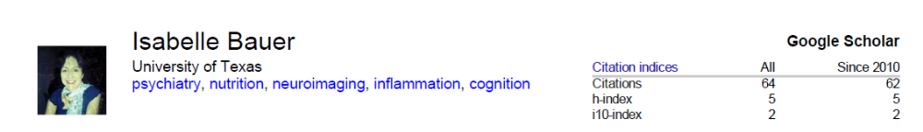

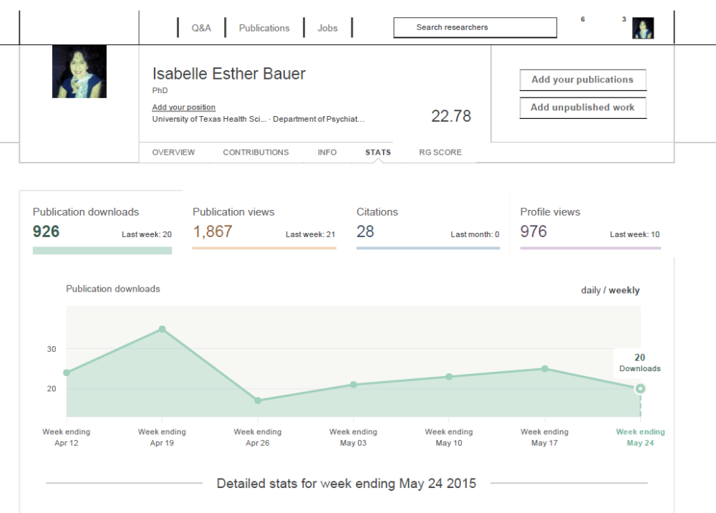
Figure 1. The geographic locations for publications that have cited my work.

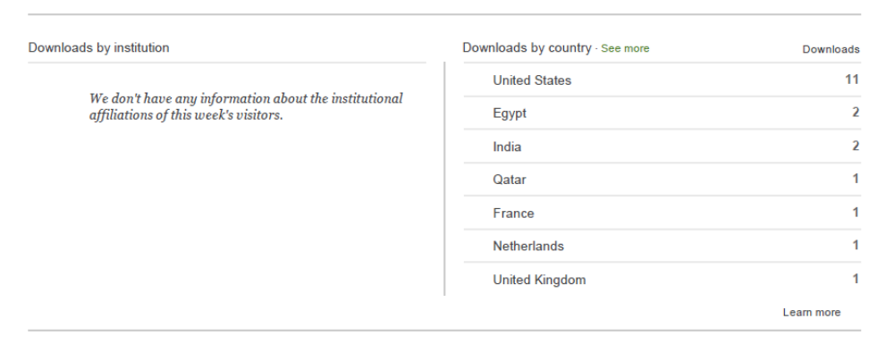

Review of Peer’s Research Work

In recognition of my outstanding research accomplishments and significant influence in the field of nutrition and psychiatry, I have been frequently called upon to serve as a judge of the work of other research scientists in the field. I have served as an ad hoc reviewer and joint reviewer with my current PI Professor Jair C. Soares for the following journals: Biological Psychiatry, JAMA Psychiatry, Journal of Affective Disorders, Psychiatry Research: Neuroimaging, Behavioral Neurology, Human Psychopharmacology: Clinical and Experimental, Annals of Nutritional Disorders & Therapy, Revista Brasileira de psiquiatria, and Schizophrenia research. As a reviewer, I review the manuscripts submitted by researchers in the field, and make recommendations to the journal's editorial boards regarding whether the manuscript merits publication as a valuable original scientific finding.

Please note that Biological Psychiatry is the official journal of the Society of Biological Psychiatry. It covers a broad range of topics in psychiatric neuroscience and therapeutics. Both basic and clinical contributions are encouraged from all disciplines and research areas relevant to the pathophysiology and treatment of major neuropsychiatric disorders. Novel results of original research, in Archival and Brief Report formats, Commentaries, and Correspondence judged to be of high impact to the field are published, particularly those addressing genetic and environmental risk factors, neural circuitry and neurochemistry, and important new therapeutic approaches. Concise Reviews and Editorials that focus on topics of current research and interest are also published rapidly. According to the Scientific Journal Ranking published by the SCImago Journal & Country Rank, Biological Psychiatry ranks #7 by impact factor among the top 517 scientific journals in the field of Neuroscience.

The Journal of Affective Disorders publishes papers concerned with affective disorders in the widest sense: depression, mania, anxiety and panic. It is interdisciplinary and aims to bring together different approaches for a diverse readership. High quality papers will be accepted dealing with any aspect of affective disorders, including biochemistry, pharmacology, endocrinology, genetics, statistics, epidemiology, psychodynamics, classification, clinical studies and studies of all types of treatment. According to the Scientific Journal Ranking published by the SCImago Journal & Country Rank, the Journal of Affective Disorders ranks #3 among the top 517 scientific journals in the field of Neuroscience.

Please note that JAMA Psychiatry (formerly Archives of General Psychiatry) is an international highly selective peer-reviewed journal for clinicians, scholars, and research scientists in psychiatry, mental health, behavioral science, and allied fields. It has a high impact factor (13.75),extensive press coverage, with news releases of major articles distributed each week to more than 5000 journalists worldwide, with 11,191 media mentions in print, online, and broadcast in 2014. According to the Scientific Journal Ranking published by the SCImago Journal & Country Rank, JAMA ranks #1 in terms of number of citations among the top 490 scientific journals in the field of Psychiatry and Mental Health.

See the table below for a summary of the Journal Rankings of the journals that have invited me to serve as a journal reviewer.

Name of Journal | Journal Ranking | Circulation
JAMA Psychiatry | #1 journal among the top cited scientific journals in the field of Psychiatry and Mental Health | International
Journal of Affective Disorders | #3 journal among the top 50 cited scientific journals in the field of Psychiatry and Mental Health | International
Biological Psychiatry | #7 journal among the top 517 scientific journals in the field of Neuroscience | International
Peer-review process is a pillar of modern scientific publication system, and it is essentially the reviewer who decides whether a manuscript has enough scientific value to be published or not. For this reason journals select their reviewers very carefully, and only invite individuals with proven reputation in the field. The fact that I have been invited to serve as a journal reviewer for a number of international scientific journals is an attestation of my respected status among my peers in the field and has placed me above the majority of my peers.

Evidences submitted include:

Biological Psychiatry

(1) certified copy of the profile of Biological Psychiatry

(2) certified copy of the above-mentioned paper that Dr. Bauer has reviewed for Biological Psychiatry

(3) certified copy of the letter from Rhiannon Bugno, Managing Editor of Biological Psychiatry, who certifies that Dr. Bauer served as a journal reviewer for Biological Psychiatry in 2014. Ms Bugno states in this letter that:” As a preeminent scientific journal, Biological Psychiatry requires peer reviewers to determine the significance, validity and quality of manuscripts submitted for publication. The peer review process ensures that only significant research findings are published, and is an objective process carried out by all reputable scientific journals. Therefore, the referees play a vital role in maintaining the high standards of Biological Psychiatry by reviewing and providing input to the editor(s) as to the suitability of a particular manuscript for publication. Peer reviewers must provide unbiased, independent, critical assessments of the work under review, and maintain the confidentiality of all manuscripts. Peer reviewers are selected based upon their particular topics of expertise and their scientific reputations”.

Annals of Nutritional Disorders and Therapy

- certified copy of the profile of Annals of Nutritional Disorders and Therapy
- certified copy of the e-mail from Helen Ruth, Editorial Manager of Annals of Nutritional Disorders and Therapy, who requested Dr. Bauer’s assistance in reviewing a paper entitled “Obesity: A Brief Approach to this New Pandemia” submitted to the journal for possible publication.

Behavioural Neurology

- certified copy of the profile of Behavioural Neurology
- certified copy of the e-mail from Hebatallah Mahmoud and Salma Gamal (Editorial office of Behavioral Neurology), who thanked Dr. Bauer’s assistance in reviewing a paper entitled “Frontal lobe involved in conceptual explicit and implicit memory process: evidence in favor of component process model” and “Neuronal responses by visual stimulation of main-dish foods and sweets during hunger and satiety: A functional MRI study in young Japanese men” submitted to the journal for possible publication.

Psychoneuroendocrinology

(1) certified copy of the profile of Psychoneuroendocrinology
(2) certified copy of the e-mail from Dr. Robert Dantzer, Editor-in-Chief of Psychoendocrinology, who thanked Dr. Bauer for her review of the papers entitled “Gene-environment interaction between the brain-derived neurotrophic factor Val66Met polymorphism, psychosocial stress and dietary habits in the psychosis prodrome” and “Polymorphisms in the serotonergic and adrenergic pathways: partial overlap in susceptibility loci for heroin and cocaine addiction in cohorts of African and European ancestry”

Human Psychopharmacology: Clinical and Experimental
- certified copy of the profile of Human Psychopharmacology: Clinical and Experimental
- certified copy of the e-mail from Dr Andrew Mayers, Managing Editor of Human Psychopharmacology: Clinical and Experimental, who thanked Dr. Bauer’s assistance in reviewing a paper entitled “The potential role of atypical antipsychotics in the treatment of panic disorder” submitted to the journal for possible publication.

Journal of Affective Disorders

- certified copy of the profile of Journal of Affective Disorders

- certified copy of the e-mail from Dr. Cornerlius Catona, Editor-in-Chief of Journal of Affective Disorders, who requested Dr. Bauer’s assistance in reviewing a paper entitled “Verbal Learning Impairment in Euthymic Bipolar Disorder: BDI v BDII Journal of Affective Disorders”

- certified copy of the e-mail from Dr. Cornerlius Catona, Editor-in-Chief of Journal of Affective Disorders, who thanked Dr. Bauer for her review of the paper entitled “Verbal Learning Impairment in Euthymic Bipolar Disorder: BDI v BDII Journal of Affective Disorders”

JAMA Psychiatry

- certified copy of the profile of JAMA Psychiatry
- certified copy of the e-mail from Dr. Jenni Blackford, Managing Editor of JAMA Psychiatry, who thanked Dr. Bauer for her review of the paper entitled “Developmental Meta-Analyses of the Functional Neural Correlates of Bipolar Disorder”.

Revista Brasileira de Psiquiatria

- certified copy of the profile of Revista Brasileira de Psiquiatria
- certified copy of the e-mails from Prof. Rafael Freire, Managing Editor of Revista Brasileira de Psiquiatria, who invited and thanked Dr. Bauer’s assistance in reviewing a paper entitled “Cognition and functioning in bipolar depression”.

Membership in Prestigious Associations

I am a Member of the International Society for Clinical trials and Methodology (ISCTM). This membership is open to post-doctoral research fellows working or studying in the field of CNS clinical trials.

Presentations at International Professional Conferences

Because of my expertise, I have been invited to make numerous presentations in several national and international professional conferences including the 69th Annual Scientific Meeting of the Society of Biological Psychiatry, the 11th Annual Meeting of the International Society for Clinical Trials and Methodology, the 13th Annual Pharmacogenetics in Psychiatry Meeting and the 15th Annual Meeting for Human Brain Mapping.

Please see the table below for a summary of the conference presentations that I have attended.

Name of Conference | Type and Year | Country
11th Annual Meeting of the International Society for Clinical trials and Methodology (ISCTM) | Poster presentation | USA
13th Annual Pharmacogenetics in Psychiatry Meeting | Poster presentation | USA
Society of Biological Psychiatry, 69th Annual Scientific Meeting | Poster presentation | USA
20th Annual Neuroscience Poster Session – University of Texas | Poster presentation | USA
Australasian Cognitive Neuroscience Society Conference | Poster presentation | Australia
Brain Health and Natural Medicine | Oral presentation | Australia
International Conference on the science of nutrition in medicine and healthcare | Oral presentation | Australia
Australasian Cognitive Neuroscience Society Conference | Poster presentation | Australia
International Seafood and Health Conference | Oral presentation | Australia
Pharmacy Expo | Oral presentation | Australia
15th Annual Meeting Human Brain Mapping | Poster presentation | USA

Reports by News Media

My important work on omega-3 fatty acids and cognition was discussed in NutraIngredients-USA (02/11/2014), UrbanPost (01/29/2015), NutraIngredient – USA (02/25/2014), NutriNat (04/15/2014), Nutricity (03/18/2014), Omegor (05/29/2014).

NutraIngredients-USA.com is a daily online news service available as a free-access website and provides daily and weekly newsletters to subscribers. The service seeks out news stories and data of value to decision-makers in the North American dietary supplements and functional food markets. The NutraIngredients-USA.com team is led by award-winning journalists. They scan all available scientific, technical and industry sources and search out previously unpublished material, primary data and expert opinions in all areas of significance to the target audience.
UrbanPost is an Italian online news service written by bloggers and journalists and focusing on primary data and expert opinions in all areas of significance to the target audience.

NutriNat is a Spanish online news service that focuses on natural dietary supplements. It promotes new products and reports research finding data of value to decision-makers in the European supplements and functional food markets.

Nutricity is an online news service focused on providing the most comprehensive portfolio of products and services that help people lead healthier lives.. Nutricity also offers over 35,000 different products that range from organic and healthy foods, vitamins, supplements, minerals, herbs, sports nutrition, homeopathic remedies and healthy pet supplies.

Omegor is an Italian pharmaceutical company producing premium essential fatty acid products. Its online news service focuses on providing the most comprehensive portfolio of products and services that help people lead healthier lives at the lowest possible costs.

